**DON'T CALL ME TURKEY!**

In this competition the task is finding the turkey sound signature from pre-extracted audio features.

## **DATASET**

This dataset is based on AudioSet’s data .

## File descriptions

* **train.json** - the training set
* **test.json** - the test set
* **sample_submission.csv** - a sample submission file in the correct format

## Data fields

* **vid_id** - YouTube video ID associated with this sample.
* **start_time_seconds_youtube_clip** - Where in the YouTube video this audio feature starts.
* **end_time_seconds_youtube_clip** - Where in the YouTube video this audio feature ends.
* **audio_embedding** - Extracted frame-level audio feature, embedded down to 128 dimensions per frame using AudioSet’s VGGish.
* **is_turkey** - The target: whether or not the original audio clip contained a turkey. Label is a soft label, based on whether or not AudioSet’s ontology labeled this clip with “Turkey”, and may count turkey calls and other related content as being “turkey”. is_turkey is 1 if the clip contains a turkey sound, and 0 if it does not.

**STEP 1: IMPORTING THE LIBRARIES**

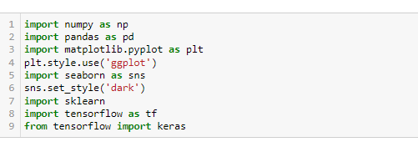

**STEP 2: DATA LOADING**

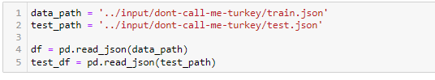

**STEP 3: DATA PREPATION**

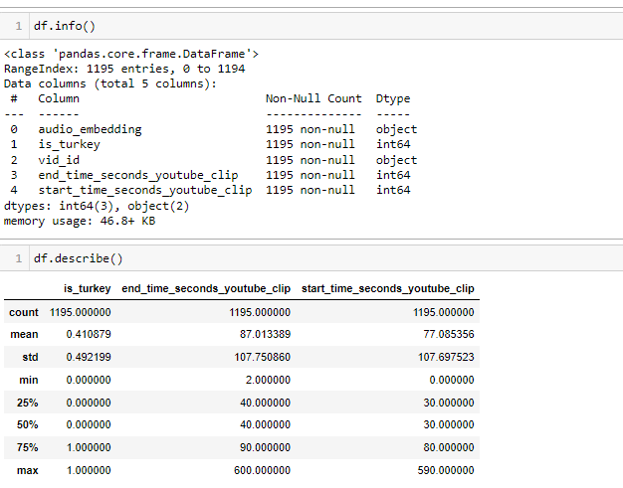

**STEP 4: DATA PREPROCESSING**

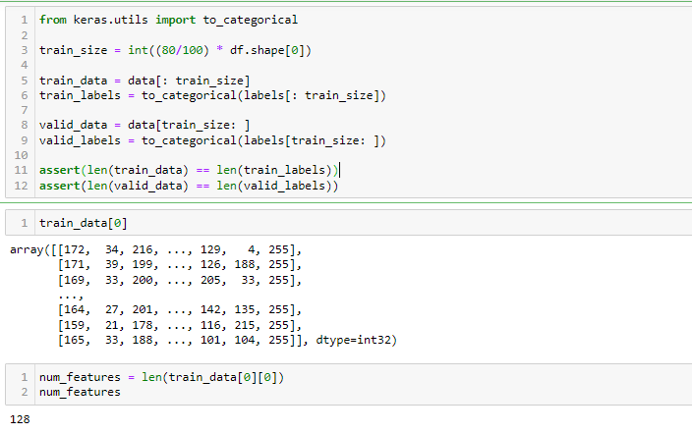

**STEP 5: BUILDING AND COMPILING THE MODEL**

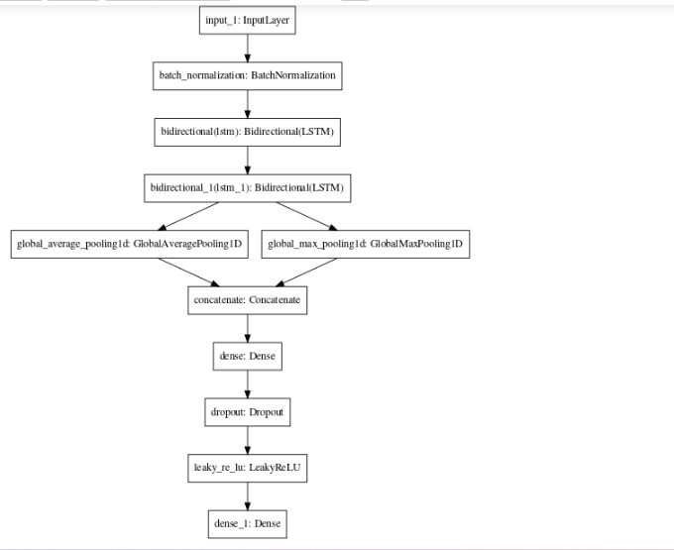

**STEP 6: TRAINING THE MODEL**

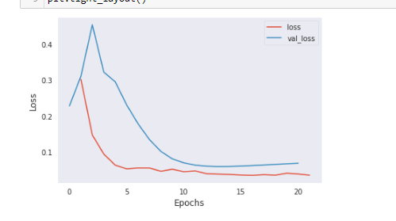

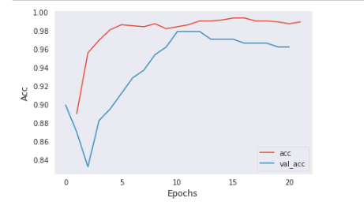

**STEP 7: PREDICTIONS**

